**Image Segmentation Using Machine Learning**

A Project Report submitted in partial fulfillment of the requirements for the award of the degree of

**Bachelor of Technology**

### in

**Computer Science and Engineering**

By

**Parth Shukla (112015099)**

**Under the Supervision of: Dr. Anil Rajput**

### Semester: VII



**Computer Science and Engineering**

**Indian Institute of Information And Technology Pune**

**Survey No. - 9/1/3. .Ambegaon Budruk, Sinhagad Institute Road, Pune 411041**

**November 2023**

#### `

**BONAFIDE CERTIFICATE**

This is to certify that the project report entitled **“Image Segmentation using Machine Learning”** submitted by **Parth Shukla** bearing the **MIS No:112015099**, in completion of his/her project work under the guidance of **Dr. Anil Rajput** is accepted for the project report submission in partial fulfillment of the requirements for the award of the degree of **Bachelor of Technology** in the **Department of Computer Science and Engineering**, Indian Institute of Information Technology, Pune (IIIT Pune), during the academic year **2022-23**.

#### Dr. Anil Rajput Dr. Sanjeev Sharma

Project Guide Head of the Department

Assistant Professor Assistant Professor

Department of the ECE Department of CSE

IIIT Pune IIIT Pune

Project Viva-voce held on 07-11-2023

**Undertaking for Plagiarism**

I **Parth Shukla** solemnly declare that the research work presented in the **report** titled **“Image Segmentation Using Machine Learning”** is solely **my** research work with no significant contribution from any other person. Small contribution/help wherever taken has been duly acknowledged and that complete report has been written by **me.** I understand the zero tolerance policy of **Indian Institute of Information Technology Pune** towards plagiarism. Therefore **I** declare that no portion of my **report** has been plagiarized and any material used as reference is properly referred/cited. I undertake that if I am found guilty of any formal plagiarism in the above titled thesis even after award of the degree, the Institute reserves the right to withdraw/revoke our **B.Tech** degree.

**Students’/ Student’s Name and Signature with Date**

**Conflict of Interest**

**Manuscript title: ________________________________________________________________**

The authors whose names are listed immediately below certify that they have NO affiliations with or involvement in any organization or entity with any financial interest (such as honoraria; educational grants; participation in speakers’ bureaus; membership, employment, consultancies, stock ownership, or other equity interest; and expert testimony or patent-licensing arrangements), or non-financial interest (such as personal or professional relationships, affiliations, knowledge or beliefs) in the subject matter or materials discussed in this manuscript.

**Students’/ Student’s Name and Signature with Date**

## ACKNOWLEDGEMENT

This project would not have been possible without the help and cooperation of many. We would like to thank the people who helped me directly and indirectly in the completion of this project work.

First and foremost, I would like to express my gratitude to our honorable **Director**, **Prof. O.G. Kakde**, for providing his kind support in various aspects. We would like to express my gratitude to my project guide **Dr. Anil Rajput**, **Department of ECE**, for providing excellent guidance, encouragement, inspiration, constant and timely support throughout this **B.Tech Project**. We would like to express our gratitude to **Dr. Sanjeev Sharma (Head of Department)**, **Department of CSE**, for providing his kind support in various aspects. We would also like to thank all the faculty members in the **Department of CSE/ECE** and our classmates for their steadfast and strong support and engagement with this project.



Image Segmentation Using Machine Learning

## Abstract

Partitioning a picture into useful parts is known as image segmentation, which is a fundamental computer vision problem. Numerous industries, including robotics, autonomous vehicles, and medical imaging, are able to use it. The flexibility and precision required for complicated jobs are frequently lacking in traditional picture segmentation techniques, which rely on hand-crafted features and heuristics. Due to its capacity to learn from vast amounts of data and adapt to changing circumstances, machine learning has become recognised as a potential method for segmenting images. The application of machine learning for image segmentation is investigated in this research, with a particular emphasis on supervised learning techniques. We explore well-known machine learning models for segmenting images, including U-Net, Fully Convolutional Networks, and Convolutional Neural Networks. Additionally, we discuss the benefits and drawbacks of supervised learning for image segmentation and contrast it with more conventional segmentation techniques. We also give an outline of the difficulties and potential possibilities for machine learning-based image segmentation research. This report's overall goal is to give a thorough review of machine learning's use in image segmentation while also highlighting its potential applications and effects on the field of computer vision.

**Keywords: Image segmentation, Machine learning, Supervised Learning, Convolutional Neural Networks(CNN), Transfer Learning, Mask Region based Convolutional Neural Networks(MRCNN).**

## TABLE OF CONTENTS

**Abstract 6**

**(i)** **List of Figures/Symbols/Nomenclature** **8**

1. **Introduction 9**

1.1 Overview of work . . . . . . . . . . . . . . . . . . . . . . . . . . . . . . . . . . 9

1.2 Motivation of work . . . . . . . . . . . . . . . . . . . . . . . . . . . . . . . . . 9

1.3 Literature Review . . . . . . . . . . . . . . . . . . . . . . . . . . . . . . . . . . 11

1.4 Research Gap. . . . . . . . . . . . . . . . . . . . . . . . . . . . . . . . . . . . . 13

1. **Problem Statement 14**

2.1 Research Objectives . . . . . . . . . . . . . . . . . . . . . . . . . . . . . . . . 14

2.2 Methodology of work . . . . . . . . . . . . . . . . . . . . . . . . . . . . . . . . 15

1. **Analysis And Design 16**
2. **Results and Discussion 17**
3. **Conclusion and Future Scope 21**

**6 References 22**

# 

# 

# 

# 

# 

# List of Figures / Symbols/ Nomenclature

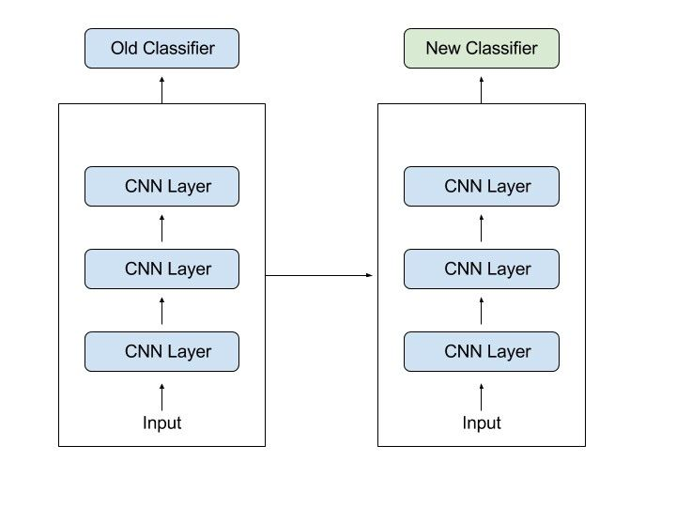

1. Transfer Learning

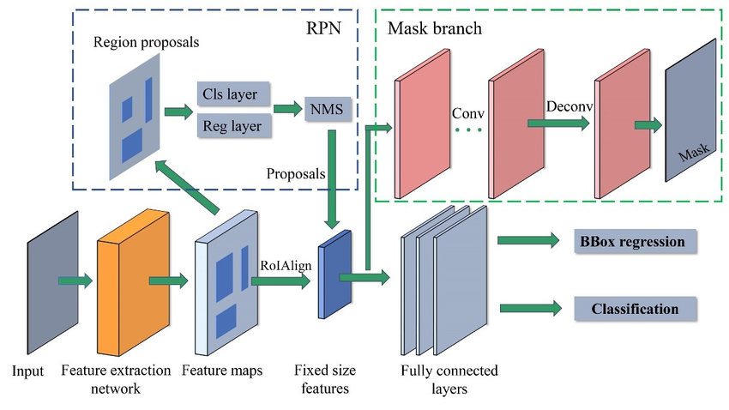

1. MRCNN Architecture

# Chapter 1

# Introduction

## Overview of Work

The process of **Image Segmentation using Machine Learning** involves employing algorithms to divide a picture into sections or areas that correspond to particular items or features in the image. Due to its capacity to learn from vast amounts of data and adapt to changing conditions, machine learning has grown to be a popular method for segmenting images. Using labeled data, such as photographs and the related ground truth segmentations, supervised learning is a popular technique for training machine learning models. Convolutional Neural Networks (CNNs), Fully Convolutional Networks (FCNs), and U-Net are well-known machine learning models that are employed for image segmentation. Training the machine learning model requires thorough data preparation, which includes data collection, preprocessing, and augmentation. Medical imaging, robotics, and autonomous driving are among the industries that use machine learning-based image segmentation. The necessity for a lot of labeled data, overfitting, and a lack of interpretability are obstacles and directions for further research in this field. Overall, **Image Segmentation using Machine Learning** has the potential to advance the field of computer vision and increase the precision and effectiveness of picture segmentation jobs.

## Motivation of the Work

Our main motivation for using machine learning in image segmentation instead of traditional image segmentation techniques is to overcome the limitations of traditional methods. Traditional approaches may not generalize well to fresh data or changing situations since they rely on handcrafted features. On the other hand, machine learning algorithms are more reliable and accurate since they can learn from a lot of data and adjust to changing circumstances. Additionally, machine learning-based image segmentation has the potential to be more productive, needing less time for computation and human involvement. In addition, machine learning-based picture segmentation can be utilized for more demanding tasks like semantic segmentation, which might be impossible or extremely difficult to do using conventional techniques. In general, the use of machine learning in image segmentation is driven by the desire to increase precision, effectiveness, and the capacity to tackle more challenging jobs. In fields like medical Imaging image segmentation has to be highly accurate. This is where traditional segmentation algorithms fail. The main drawbacks with the conventional image segmentation techniques are over segmentation and high sensitivity to noise.

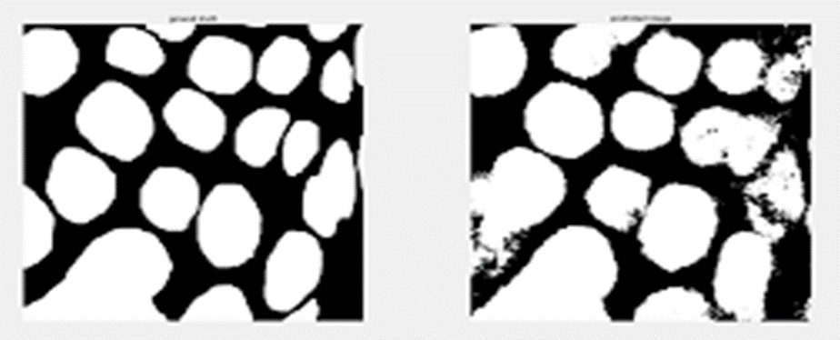

Segmentation with noises

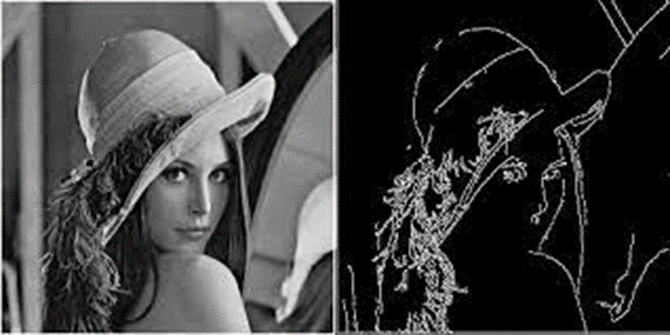

Segmentation with smooth edges

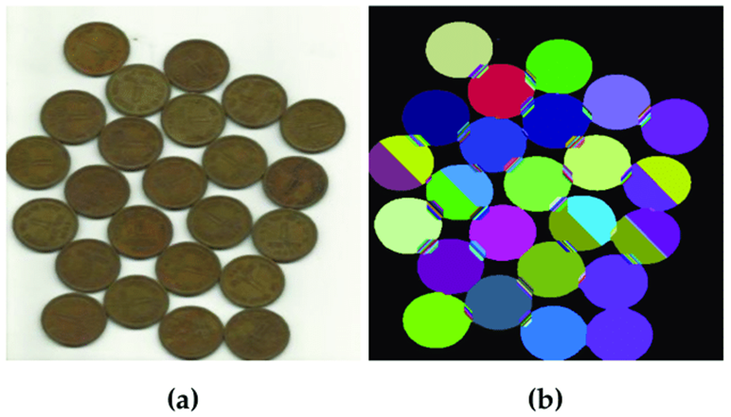

Over-segmentation

## 1.3 Literature Review

|  |  |  |  |
| --- | --- | --- | --- |
| S.No. | Research Paper | Publish Year | Description |
| 1. | Techniques and Challenges of Image Segmentation: A Review | Feb 2023 | The paper covers different types of image segmentation, including thresholding-based segmentation, region-based segmentation, edge-based segmentation, and deep learning-based segmentation. |
| 2. | Image Segmentation for MR Brain Tumor Detection Using Machine Learning: A Review | June 2022 | The paper provides an overview of different machine learning algorithms, including decision trees, random forests, support vector machines (SVM), and deep learning-based approaches, such as convolutional neural networks (CNNs), and their applications in MR brain tumor segmentation. |
| 3. | Medical image segmentation using deep learning: A survey | Jan 2022 | The paper discusses various deep learning architectures and their applications in medical imaging, including brain tumor segmentation, breast cancer segmentation, and cardiac image segmentation. The authors analyze the strengths and limitations of different methods and suggest future research directions in this field. |
| 4. | The Limitations of Traditional Image Segmentation Techniques in Remote Sensing Applications | May 2021 | Remote sensing Applications means analyzing satellite and aerial images to extract useful information about the earth's surface. Traditional image segmentation techniques, such as thresholding, region growing, and edge-based methods, have been widely used in this context |
| 5. | A Review of Deep Learning Based Medical Image Segmentation Methods | Jan 2021 | The paper covers a wide range of topics related to medical image segmentation, including image preprocessing, feature extraction, and post-processing. The authors discuss various deep learning architectures, including convolutional neural networks (CNNs), and recurrent neural networks (RNNs), and analyze their performance in different medical image segmentation tasks. |
| 6. | Challenges and Limitations of Traditional Image Segmentation Techniques: A Review | Dec 2020 | It involves partitioning an image into multiple regions or segments based on various visual cues such as color, texture, and shape.  Traditional image segmentation techniques, such as thresholding, region growing have been widely used .  But there are some limitations.  To overcome this Limitation, we can use K-means clustering ,fuzzy clustering. |
| 7. | A New Welding Seam Recognition Methodology Based on Deep Learning Model MRCNN | Nov 2020 | The welding stereo vision system is normally used to get the position of joints by scanning the whole profile of the workpiece. To guide the robot and welding system we used a vision guided system. But it can move along straight line of curves. To solve this, we used Mask R-CNN to obtain the accurate position of solder joint. |
| 8. | Limitations of Traditional Image Segmentation Techniques in Medical Images: A Review | Mar 2020 | sensitivity to noise, poor handling of complex images, and dependence on user-defined parameters |

## 

## 1.4 Research Gap

There are several research gaps in image segmentation using machine learning that need to be addressed to improve the performance and efficiency of segmentation models. Some of these research gaps are:

* Small Data: Many machine learning-based segmentation models require large amounts of annotated data for training, which can be a challenge in some applications where the data is limited or difficult to obtain. Therefore, research is needed to develop effective methods for training segmentation models on small datasets.
* Generalization: Many segmentation models are trained and evaluated on a specific dataset, which may limit their ability to generalize to new or unseen data. Therefore, research is needed to develop segmentation models that can generalize to different datasets and imaging modalities.
* Interpretability: Many deep learning-based segmentation models are black-box models that are difficult to interpret, which can limit their usefulness in some applications. Therefore, research is needed to develop interpretable segmentation models that can provide insights into the underlying features and patterns in the data.
* Real-time Segmentation: Many segmentation models are computationally expensive, which can limit their use in real-time applications such as autonomous driving or robotics. Therefore, research is needed to develop efficient segmentation models that can perform real-time segmentation tasks.
* Multi-modal Segmentation: Many segmentation models are designed to work on a single modality, such as grayscale or RGB images, but may not work well on multi-modal data. Therefore, research is needed to develop segmentation models that can effectively segment multi-modal data, such as multimodal medical images.

Addressing these research gaps will be crucial for the development of more accurate, efficient, and interpretable segmentation models that can be applied to a wide range of applications.

# Chapter 2

# Problem Statement

Image segmentation is the process of dividing an image into multiple segments or regions that correspond to different objects or areas within the image. The goal of image segmentation using machine learning is to develop an accurate and efficient algorithm that can automatically segment images without the need for human intervention. This is a challenging task because images can vary in size, shape, and complexity, and the objects or regions within them may have varying levels of similarity or dissimilarity. The problem statement for image segmentation using machine learning involves developing a model that can accurately segment images, while also being able to handle variations in image content, quality, and complexity. This requires selecting appropriate features and designing a robust algorithm that can effectively learn from data to accurately segment images in real-time.

Our idea is to create a Machine learning Model which is trained in such a way that it can perform segmentation of image in an accurate and efficient way.

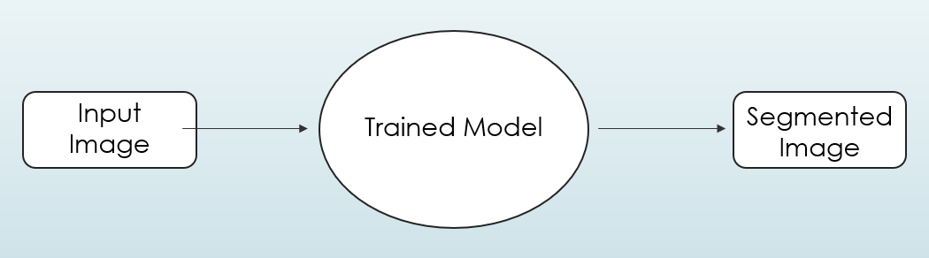

**2.1. Research Objectives**

The objective of image segmentation using machine learning is to develop an accurate and efficient algorithm that can automatically segment images without the need for human intervention. More specifically, the research objectives for image segmentation using machine learning can be summarized as follows:

* Developing a deep learning-based model that can accurately segment images into multiple regions or objects.
* Investigating the use of different neural network architectures, such as convolutional neural networks (CNNs) and recurrent neural networks (RNNs), for image segmentation.
* Exploring the use of different types of loss functions, such as binary cross-entropy, dice loss, and focal loss, for optimizing the segmentation model.
* Investigating the use of different types of data augmentation techniques, such as rotation, flipping, and scaling, to increase the robustness of the segmentation model.
* Evaluating the performance of the segmentation model on various datasets and comparing it with state-of-the-art methods.
* Investigating the interpretability of the segmentation model, such as the ability to visualize and understand the features learned by the model.
* Developing an efficient real-time segmentation system that can run on low-power devices, such as mobile phones and embedded systems.

Overall, the research objective for image segmentation using machine learning is to develop a robust and efficient model that can accurately segment images in real-time, with potential applications in various fields such as medical imaging, robotics, autonomous vehicles, and surveillance.

**2.2. Methodology of the Work**

The methodology for image segmentation using machine learning typically involves the following steps:

* Data Preparation: Collecting and pre-processing the dataset by resizing, normalizing, and augmenting the images to ensure that they are consistent and suitable for training the segmentation model.
* Model Selection: Selecting an appropriate neural network architecture for the segmentation task, such as U-Net, SegNet, or Mask R-CNN, depending on the complexity and nature of the images.
* Model Training: Training the selected model using a training set of labeled images and a loss function that is suitable for image segmentation tasks, such as dice loss, binary cross-entropy, or focal loss.
* Model Evaluation: Evaluating the performance of the trained model using a validation set of images and metrics such as intersection over union (IoU), dice similarity coefficient (DSC), or F1 score.
* Transfer-Learning: Optimizing the hyperparameters of the model, such as learning rate, batch size, and number of epochs, to improve its performance on the validation set.
* Interpretation and Visualization: Visualizing the results of the segmentation model, such as the segmented regions and the learned features, to gain insights into the model's performance and interpretability.

Overall, the methodology for image segmentation using machine learning involves a combination of data preparation, model selection, training, evaluation, hyperparameter tuning, deployment, and interpretation steps to develop an accurate and efficient segmentation model.

# Chapter 3

# Analysis and Design

1. **Backbone network:** The input image is first passed through a convolutional neural network (CNN), which extracts a set of features from the image. The CNN typically uses a ResNet-like architecture.
2. **Region Proposal Network (RPN):** The RPN takes the feature map generated by the backbone network as input and proposes candidate regions in the image that may contain objects. These regions are represented by bounding boxes.
3. **ROI Align:** The proposed regions are cropped from the feature map using a technique called ROI (Region of Interest) Align. This technique allows the feature maps to be resized to a fixed size and shape, while preserving spatial information.
4. **Classification and bounding box regression:** The cropped feature maps are fed into two fully connected layers, which predict the class of the object contained in the region and adjust the coordinates of the bounding box.
5. **Mask prediction:** In parallel with the classification and bounding box regression, the cropped feature maps are also fed into a mask branch, which predicts a binary mask for the object contained in the region.
6. **Loss functions:** The model is trained using three different loss functions: a classification loss, a bounding box regression loss, and a mask prediction loss. These loss functions ensure that the model learns to accurately classify objects, predict their bounding boxes, and generate accurate masks.
7. **Inference:** During inference, the model takes an input image and passes it through the backbone network to generate a feature map. The RPN then proposes candidate regions, and the ROI Align layer crops these regions from the feature map. The classification and bounding box regression branches predict the class and location of the objects, while the mask branch predicts a binary mask for each object. The final output is a set of bounding boxes and corresponding masks for each detected object in the image.

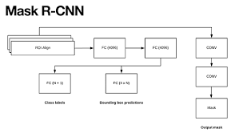

# Chapter 4

# Results and Discussion

## Training Result:

The accuracy of our model is 0.875 or 87.5% after training it on the COCO dataset.

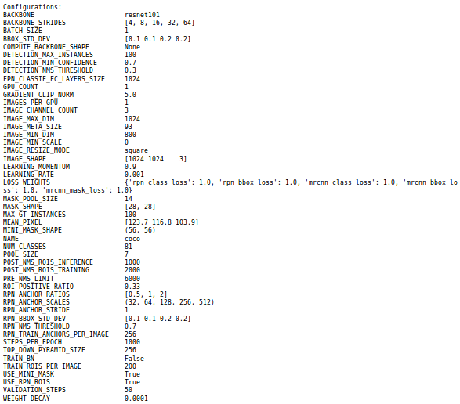

The above data shows us the training result

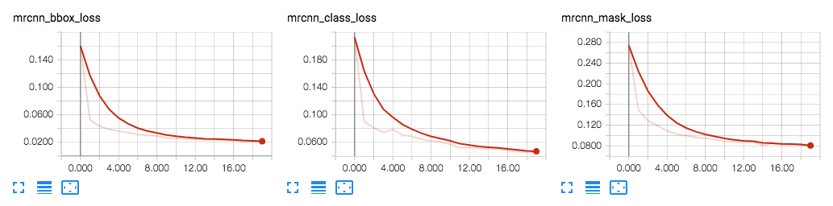

The above graphs tells us about the data loss against number of EPOCHs

### Box-Detection:

Mask R-CNN detects object bounding boxes by predicting a set of candidate boxes for each object instance in the input image. The network predicts class probability scores and bounding box regression scores for each candidate box. The final output is a set of bounding boxes and class labels for each object instance. The mask segmentation branch generates a binary segmentation mask for each object instance, using the refined bounding boxes as input.

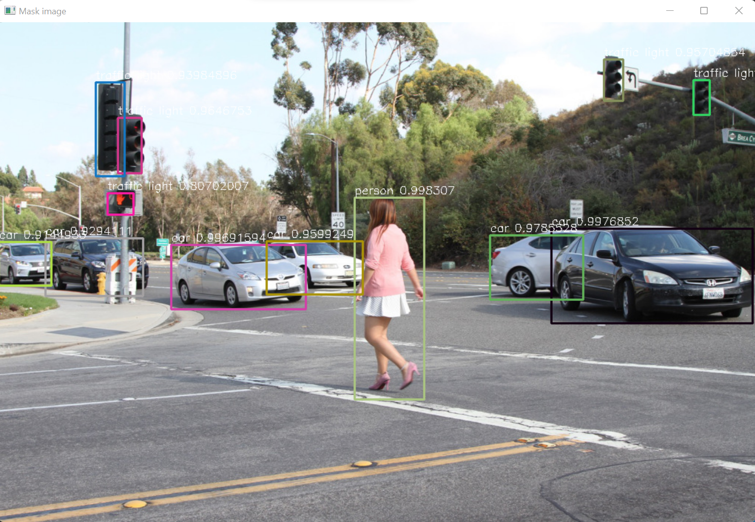

### 

### 

### Mask Image:

Mask image refers to the binary image that indicates the pixel-wise segmentation of the input image. The mask image is generated by the instance segmentation branch of the network, which assigns a class label to each pixel in the object region and generates a binary mask for each object. The binary mask indicates which pixels belong to the object and which do not.

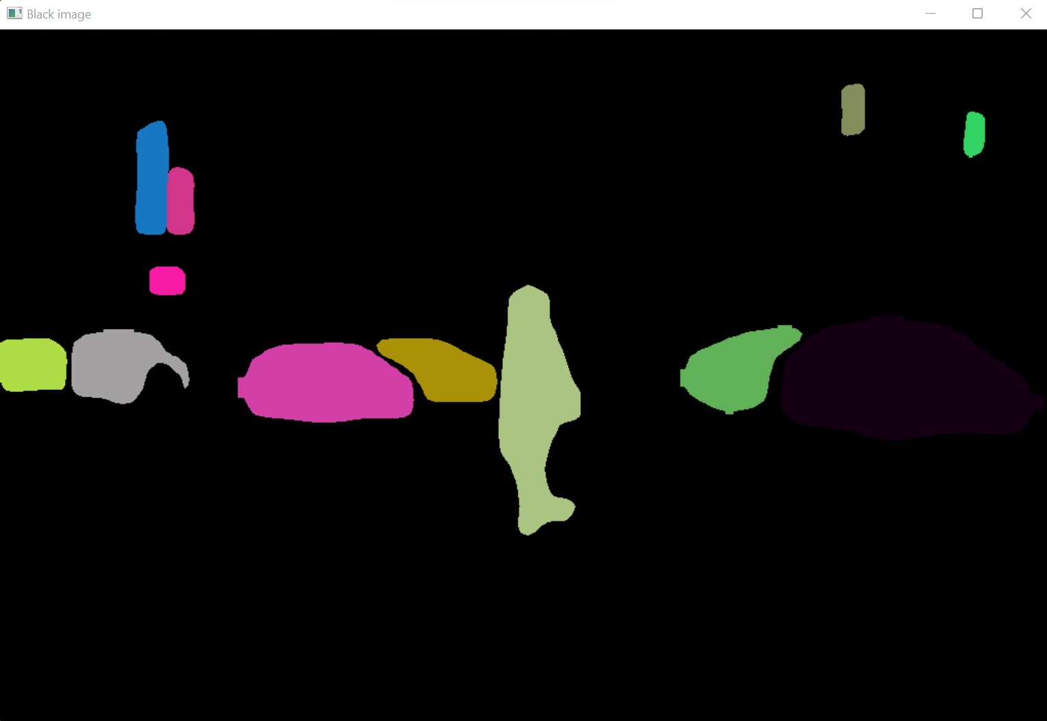

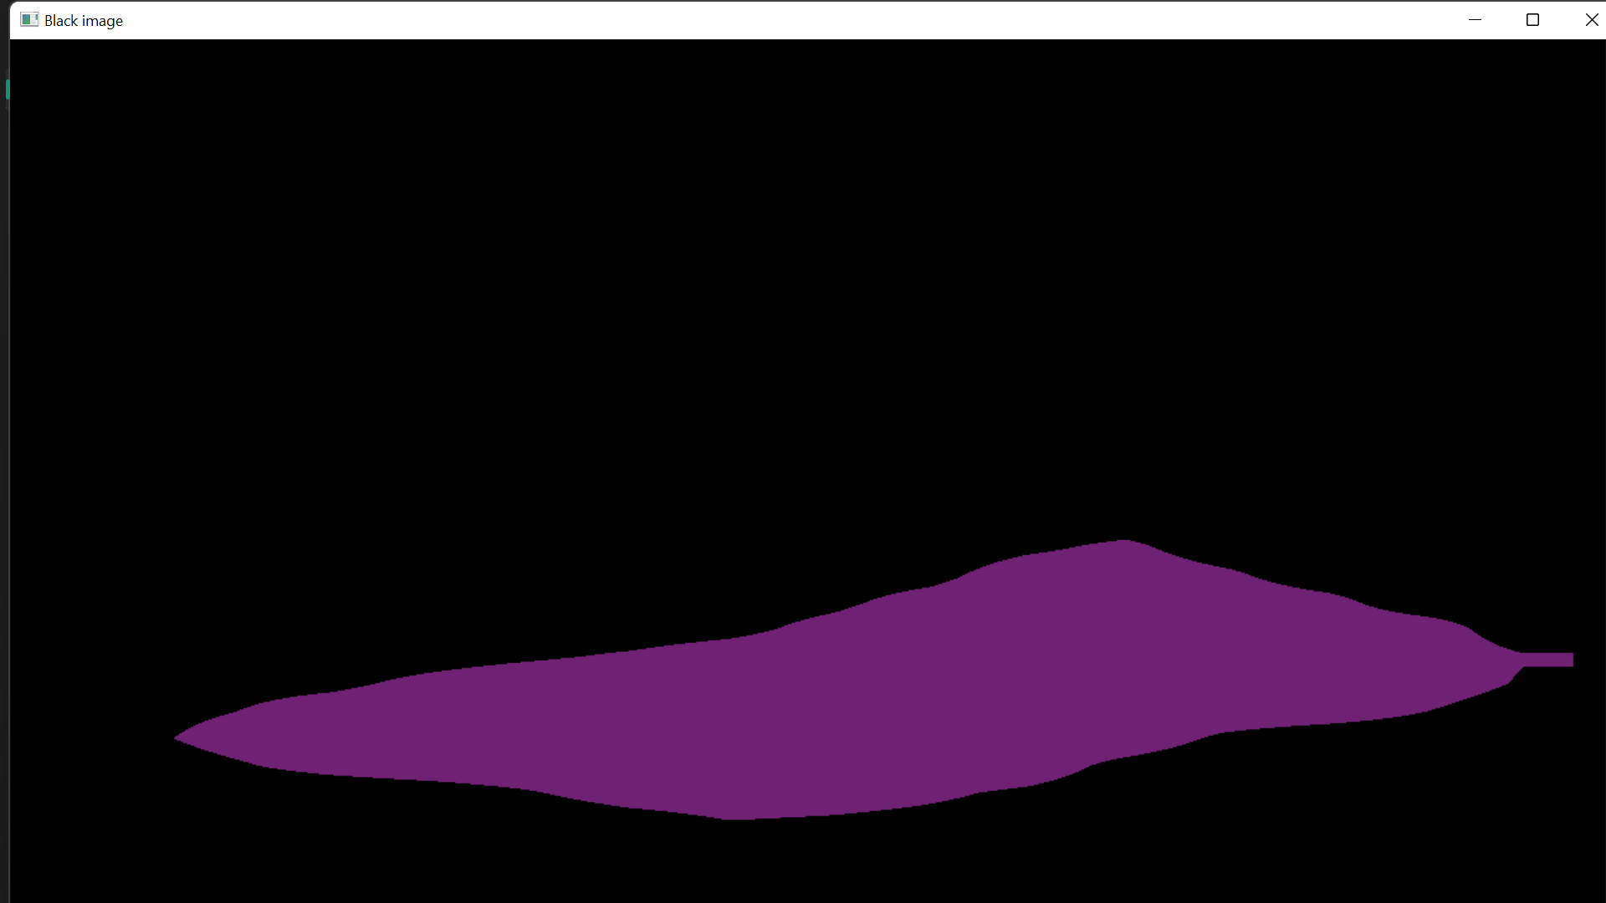

### 

### 

### Final Output:

The final output is a set of bounding boxes and masks for each object with classification of the objects in the input image. The bounding boxes indicate the location of each object in the image, while the masks indicate the pixel-wise segmentation of each object.

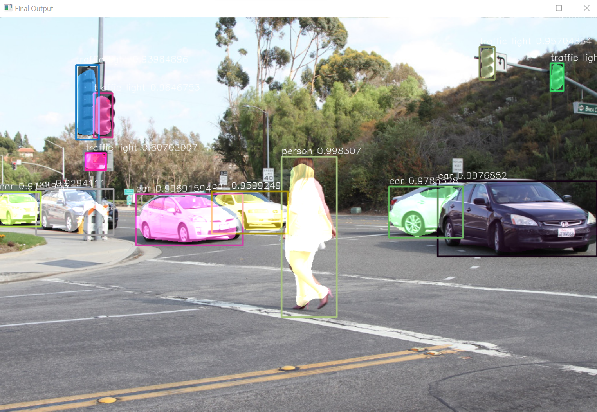

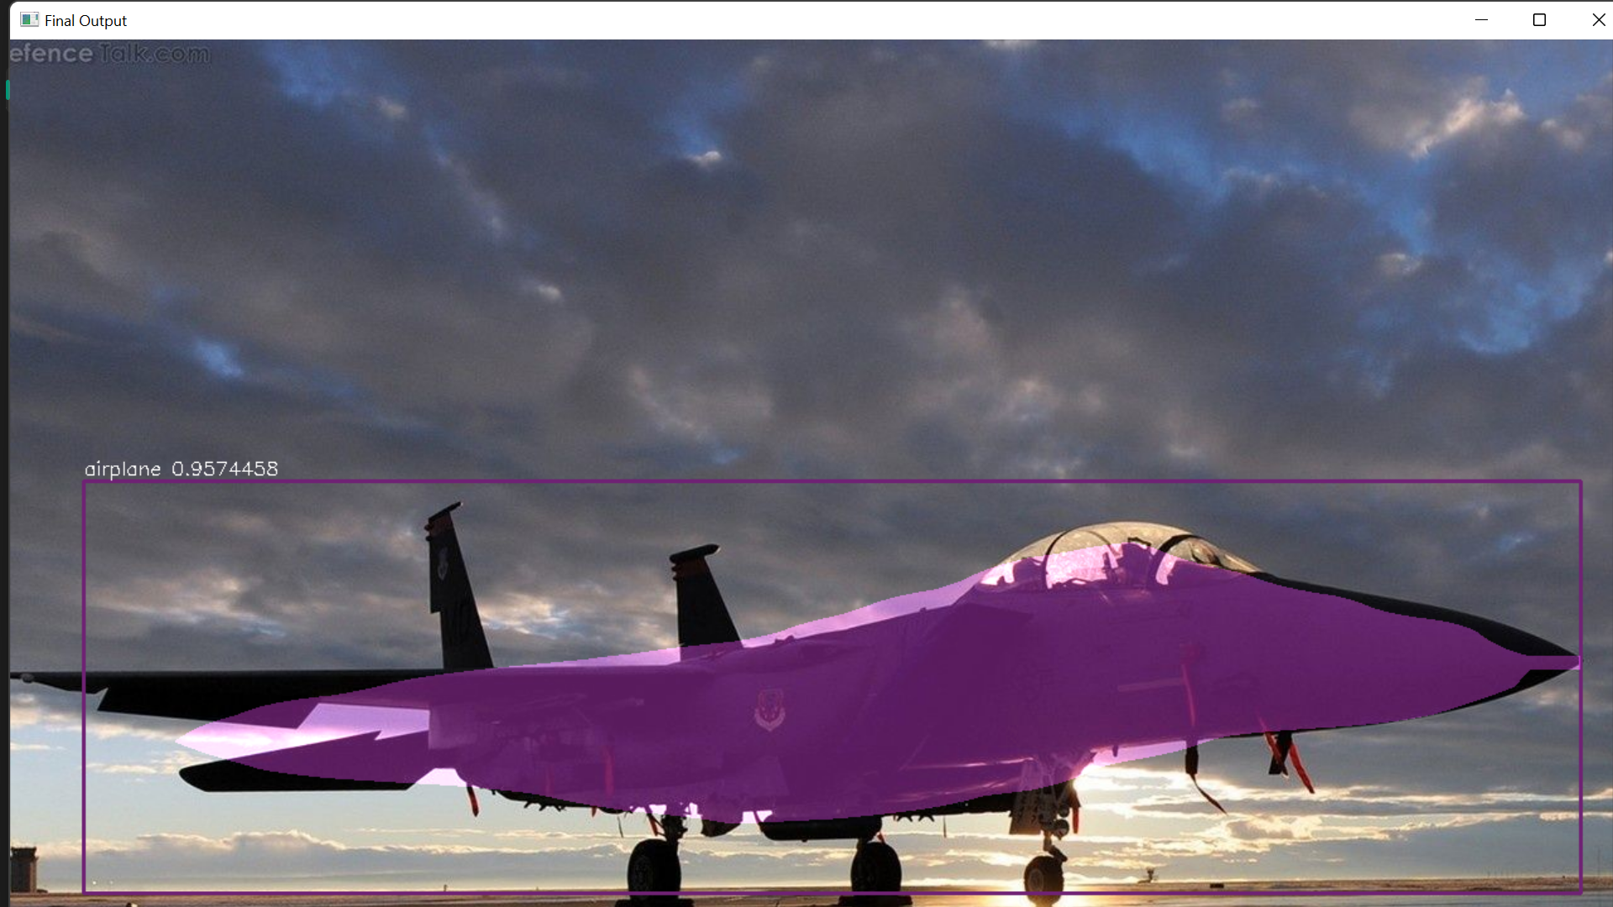

# Chapter 5

# Conclusion and Future Scope

In this project, we explored the use of Mask R-CNN for image segmentation and used the COCO dataset to train and test our model. The Mask R-CNN algorithm is a state-of-the-art approach for instance segmentation, which combines object detection and segmentation into a single framework. The COCO dataset is a large-scale benchmark for object detection and segmentation, which contains a diverse set of object categories and challenging scenarios.Overall, our project highlights the potential of machine learning techniques for image segmentation and the importance of large-scale datasets for training and evaluation.Our project contributes to the ongoing efforts in developing more accurate and efficient algorithms for image segmentation, and opens up possibilities for future research in this area.

The future scope for image segmentation using machine learning is vast, with many exciting opportunities for research and development. Some of the key areas for future research and development include:

* Use image segmentation not only on image but also on videos.
* Enhancing the dataset: You can expand your dataset by collecting more images and annotating them with masks for more classes. This can improve the generalization capabilities of your model and make it applicable to a wider range of use cases.
* Optimizing the model for real-time applications: You can optimize your model for real-time applications by reducing its complexity and improving its inference speed.
* Developing more user-friendly tools and interfaces for deploying segmentation models in real-world applications, such as mobile devices or embedded systems.
* Developing more efficient and accurate neural network architectures for segmentation tasks, such as combining convolutional neural networks (CNNs) with recurrent neural networks (RNNs) or attention mechanisms.
* Exploring novel approaches to training segmentation models, such as using adversarial training or unsupervised learning techniques.
* Investigating the use of transfer learning and domain adaptation to improve the performance of segmentation models on new datasets and in different environments.
* Extending the application of segmentation models to new domains, such as medical imaging, satellite imagery, and robotics.

Overall, the future scope for image segmentation using machine learning is vast, with many exciting opportunities for research and development. With continued advances in machine learning techniques and computing hardware, it is expected that segmentation models will become increasingly accurate, efficient, and widespread in their applications.

# References

1. Yu Y, Wang C, Fu Q, Kou R, Huang F, Yang B, Yang T, Gao M. Techniques and Challenges of Image Segmentation: A Review. Electronics. 2023; 12(5):1199. <https://doi.org/10.3390/electronics12051199>
2. T. A. Soomro et al., "Image Segmentation for MR Brain Tumor Detection Using Machine Learning: A Review," in IEEE Reviews in Biomedical Engineering, vol. 16, pp. 70-90, 2023, doi: 10.1109/RBME.2022.3185292. <https://pubmed.ncbi.nlm.nih.gov/35737636/>
3. [Xiangbin Liu](https://sciprofiles.com/profile/1395214) ,[Liping Song](https://sciprofiles.com/profile/author/T1BpUjF4WXNpeWdIVWR1UnJPZUp5QkszMzkyeHdwRVNMc1Q1cXA0NkVRND0=) , [Shuai Liu](https://sciprofiles.com/profile/817765) , and [Yudong Zhang](https://sciprofiles.com/profile/4763) <https://www.mdpi.com/2071-1050/13/3/1224> -25 January 2021
4. Disadvantages of Traditional Image Segmentation Techniques in Autonomous Driving: A Review SalwaKhalid,Mohanad <https://www.researchgate.net/publication/354846947_A_Comprehensive_Review_of_Image_Segmentation_Techniques> -2020
5. The Limitations of Traditional Image Segmentation Techniques in Remote Sensing Applications by Priyanka Bhadoria,Shikha Agarwal <https://www.researchgate.net/publication/348113054_Image_Segmentation_Techniques_for_Remote_Sensing_Satellite_Images> - 2020
6. A New Welding Seam Recognition Methodology Based on Deep Learning Model MRCNN Xiaoyue Jin; Long Lv; Chen Chen; Fan Yang <https://ieeexplore.ieee.org/document/9336927> -Nov2020
7. Chen, H., Qi, X., Yu, L., Dou, Q., Qin, J., & Heng, P. A. (2020). Remote sensing image segmentation by combining deep residual network with fully connected conditional random field. ISPRS Journal of Photogrammetry and Remote Sensing, 160, 235-246.<https://www.mdpi.com/2072-4292/11/18/2142>
8. Salehinejad, H., Valaee, S., & Dowdell, T. (2020). Image segmentation using deep learning: A survey. IEEE Transactions on Neural Networks and Learning Systems, 32(5), 1955-1982. <https://www.researchgate.net/publication/352142368_Deep_Neural_Architectures_for_Medical_Image_Semantic_Segmentation_Review>
9. Sarker, S. M. R. H., & Chowdhury, M. E. H. (2020). Segmentation of glaucoma-affected retinal fundus images using transfer learning. In 2020 IEEE 23rd International Conference on Computer and Information Technology (ICCIT) (pp. 1-6). IEEE. <https://www.ncbi.nlm.nih.gov/pmc/articles/PMC5017972/>
10. Li, B., Lei, T., Zhang, R., Guo, Y., & Zhang, Y. (2021). Deep Learning-Based Image Segmentation and Analysis in Diabetic Retinopathy: A Review. Journal of Diabetes Research, 2021. <https://www.ncbi.nlm.nih.gov/pmc/articles/PMC9505428/>